

2021

MECHATRONICS



**PROGRAM DESCRIPTION**

This program is based on the PMMI Mechatronics certification tests, which are nationally, industry-accepted, third-party credentials endorsed by the National Association of Manufacturers’ Skills Certification System.

Mechatronics Level 1

Program Schedule & Fees

###### **Fluid Power $1,199**

###### *Check Program Calendar for Next Session*

###### **PLCS 1 $1,599**

###### *Check Program Calendar for Next Session*

###### **Motor & Motor Controls $1,199**

###### *Check Program Calendar for Next Session*

###### **Industrial Electricity 1 $1,199**

###### *Check Program Calendar for Next Session*

###### **Mechanical Components 1 $1,199**

###### *Check Program Calendar for Next Session*

**MECHATRONICS CERTIFICATION Courses**

**NEXT SESSION:**

**Check Program Calendar**

*Program Fees Include:*

* + Amatrol License

(Access to eLearning)

* + PMMI Exam

## Lab Classes - Saturday

* + 8a – 2p

# 1/16/21 – 03/30/21

## Program Cost & Fees

* Amatrol License
* 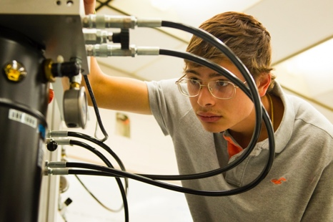PMMI Exam
  + 8a – 2p

# 1/16/21 – 03/30/21

## Program Cost & Fees

* Amatrol License
* PMMI Exam

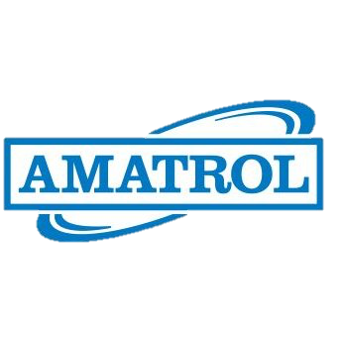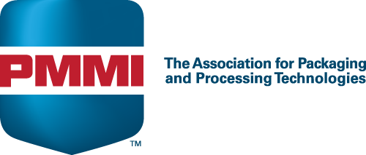

**Amskills.org**

**727.301.1282**

**Amskills.org**

