2021 Machining

Program Description
This program prepares individuals to apply technical knowledge and skills to operate Manual and Computer Numerical Control (CNC) machine tools including lathes, mills, precision measuring tools, and related attachments and accessories in order to perform machining functions such as cutting, drilling, shaping, and finishing products and component parts.
Program Schedule & Fees

Session 1 – Intro to Machining
- Measurement, Materials & Safety
- Job Planning, Benchwork & Layout
- Drill Press
Session 2 – Manual Machining
- Manual Milling
- Turning - Between Centers
- Turning - Chucking Part
- Surface Grinding
Session 3 – CNC Machining
- CNC Programming Setup &
Operations
- CNC Milling
- CNC Turning

Session 1 (Intro to Machining) $1,824

Check Program Calendar for Next Session

Session 2 (Manual Machining) $1,199

Check Program Calendar for Next Session

Session 3 (CNC Machining) $1,199

Check Program Calendar for Next Session

*Financial aid/or scholarships may be available
**NIMS Credentials Earned with Completion of each Session

727.301.1282 www.AmSkills.org
www.AmSkills.org

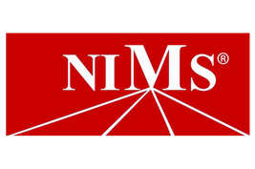
Amskills.org
727.301.1282
Machining Level 1

